XII LECTURE: Pathogenic fungi and protozoa

The purpose of the lecture:To inform students about the morpho-biological characteristics of pathogenic fungi and protozoa, pathogenicity factors, pathogenesis of diseases caused by these microorganisms, clinical signs, principles of microbiological diagnosis, treatment and prevention.
Lecture plan:
1. Classification of fungi.
2. Morpho-biological characteristics of the causative agents of superficial mycoses (dandruff, black dandruff, black and white piedra), principles of microbiological diagnosis of the diseases.
3. Morpho-biological characteristics of the causative agents of skin mycoses (trichophytia, epdermophytia, microsporia, favus), principles of microbiological diagnosis of the diseases.
4. Morpho-biological characteristics of the causative agents of subcutaneous (subcutaneous) mycoses (sporotrichosis, chromomycosis, misetoma), principles of microbiological diagnosis of the diseases.
5. Morpho-biological characteristics of the causative agents of systemic (deep) mycoses (coccidioidosis, histoplasmosis, blastomycosis, paracoccidioidosis), the principles of microbiological diagnosis of the diseases.
6. Morpho-biological characteristics of the causative agents of opportunistic (conditionally-pathogenic) mycoses (candidiasis, cryptococcosis, aspergillosis, mucoromycosis, pneumocystosis), the principles of microbiological diagnosis of the diseases.
7. The concept of mycotoxicosis.
8. Classification and causative agents of protozoal infections.
- Morpho-biological characteristics of sarcomastigophora (sarcodins and flagella), principles of microbiological diagnosis of diseases (amebiasis, trichomonas, leishmaniasis, trypanosomiasis).
- Morpho-biological characteristics of apicomplexa (spores), principles of microbiological diagnosis of diseases (balantidiosis).
- Morpho-biological characteristics of ciliophora (ciliated), the principles of microbiological diagnosis of diseases (amebiasis, trichomonas, leishmaniasis, trypanosomiasis).
9. Morpho-biological characteristics of microspora (invasion), the principles of microbiological diagnosis of diseases (microsporidiosis).

Lecture equipment: Computer, projector, electronic slides.
Literature: p.

Because fungi (yeasts and molds) are eukaryotic organisms, whereas bacteria are prokaryotic, they differ in several fundamental respects. Two fungal cell structures are important medically:(1) The fungal cell wall consists primarily of chitin (not peptidoglycan as in bacteria); thus fungi are insensitive to certain antibiotics, such as penicillins and cephalosporins, that inhibit peptidoglycan synthesis. (2) Chitin is a polysaccharide composed of long chains of N-acetylglucosamine. The fungal cell wall contains other polysaccharides as well, the most important of which is β-glucan, a long polymer of d-glucose. The medical importance of β-glucan is that it is the site of action of the antifungal drug caspofungin. (3) The fungal cell membrane contains ergosterol, in contrast to the human cell membrane, which contains cholesterol. The selective action of amphotericin B and azole drugs, such as fluconazole and ketoconazole, on fungi is based on this difference in membrane sterols. There are two types of fungi: yeasts and molds. Yeasts grow as single cells that reproduce by asexual budding. Molds grow as long filaments (hyphae) and form a mat (mycelium). Some hyphae form transverse walls (septate hyphae), whereas others do not (nonseptate hyphae). Nonseptate hyphae are multinucleated (coenocytic). The growth of hyphae occurs by extension of the tip of the hypha, not by cell division all along the filament. Several medically important fungi are thermally dimorphic (i.e., they form different structures at different temperatures).They exist as molds in the environment at ambient temperature and as yeasts (or other structures) in human tissues at body temperature.
Pathogenesis:
The response to infection with many fungi is the formation of granulomas. Granulomas are produced in the major systemic fungal diseases (e.g., coccidioidomycosis, histoplasmosis, and blastomycosis, as well as several others). The cell-mediated immune response is involved in granuloma formation. Acute suppuration, characterized by the presence of neutrophils in the exudate, also occurs in certain fungal diseases such as aspergillosis and sporotrichosis. Fungi do not have endotoxin in their cell walls and do not produce bacterial-type exotoxins. Activation of the cell-mediated immune system results in a delayed hypersensitivity skin test response to certain fungal antigens injected intradermally. A positive skin test indicates exposure to the fungal antigen. It does not imply current infection, because the exposure may have occurred in the past. A negative skin test makes the diagnosis unlikely unless the patient is immunocompromised. Because most people carry Candida as part of the normal flora, skin testing with Candida antigens can be used to determine whether cell-mediated immunity is normal.Intact skin is an effective host defense against certain fungi (e.g., Candida, dermatophytes), but if the skin is damaged, organisms can become established. Fatty acids in the skin inhibit dermatophyte growth, and hormone-associated skin changes at puberty limit ringworm of the scalp caused by Trichophyton. The normal flora of the skin and mucous membranes suppress fungi. When the normal flora is inhibited (e.g., by antibiotics), overgrowth of fungi such as C. albicans can occur.
Laboratory Diagnosis
There are four approaches to the laboratory diagnosis of fungal diseases: (1) direct microscopic examination, (2) culture of the organism, (3) DNA probe tests, and (4) serologic tests. Direct microscopic examination of clinical specimens such as sputum, lung biopsy material, and skin scrapings depends on finding characteristic asexual spores, hyphae, or yeasts in the light microscope. The specimen is either treated with 10% potassium hydroxide (KOH) to dissolve tissue material, leaving the alkali-resistant fungi intact, or stained with special fungal stains. Some examples of diagnostically important findings made by direct examination are (1) the spherules of C. immitis and (2) the wide capsule of Cryptococcus neoformans seen in India ink preparations of spinal fluid. Calcofluor white is a fluorescent dye that binds to fungal cell walls and is useful in the identification of fungi in tissue specimens. Methenamine silver stain is also useful in the microscopic diagnosis of fungi in tissue. Fungi are frequently cultured on Sabouraud’s agar, which facilitates the appearance of the slow-growing fungi by inhibiting the growth of bacteria in the specimen. Inhibition of bacterial growth is due to the low pH of the medium and to the penicillin, streptomycin, and cycloheximide that are frequently added. The appearance of the mycelium and the nature of the asexual spores are frequently sufficient to identify the organism. Tests involving DNA probes can identify colonies growing in culture at an earlier stage of growth than can tests based on visual detection of the colonies. As a result, the diagnosis can be made more rapidly. At present, DNA probe tests are available for Coccidioides, Histoplasma, Blastomyces, and Cryptococcus.

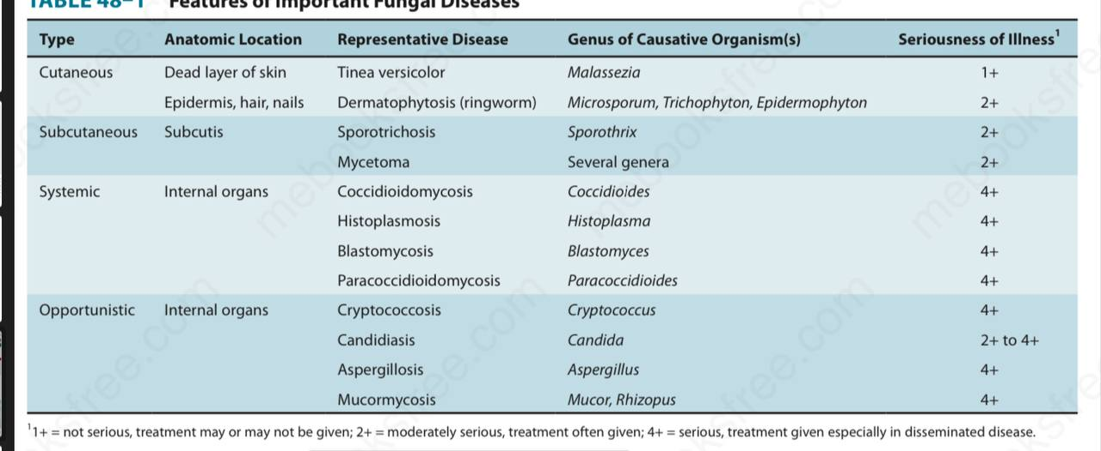
Medical mycoses can be divided into four categories: (1) cutaneous, (2) subcutaneous, (3) systemic, and (4) opportunistic.

CUTANEOUS MYCOSES
Dermatophytoses
Dermatophytoses are caused by fungi (dermatophytes) that infect only superficial keratinized structures (skin, hair, and nails), not deeper tissues. The most important dermatophytes are classified in three genera: Trichophyton, Epidermophyton, and Microsporum. They are spread from infected persons by direct contact. Microsporum is also spread from animals such as dogs and cats. This indicates that to prevent reinfection, the animal must be treated also. Dermatophytoses (tinea, ringworm) are chronic infections often located in the warm, humid areas of the body (e.g., athlete’s foot and jock itch).1 Typical ringworm lesions have an inflamed circular border containing papules and vesicles surrounding a clear area of relatively normal skin. The lesions are typically pruritic. Broken hairs and damaged nails are often seen. The disease is typically named for the affected body part (i.e., tinea capitis [head], tinea corporis [body], tinea cruris [groin], and tinea pedis [foot]). Tinea unguium, also called onychomycosis, is a disease of the nails, especially toe nails. The nails become thickened, broken, and discolored. Trichophyton tonsurans is the most common cause of outbreaks of tinea capitis in children and is the main cause of endothrix (inside the hair) infections. Trichophyton rubrum is also a very common cause of tinea capitis. Trichophyton schoenleinii is the cause of favus, a form of tinea capitis in which crusts are seen on the scalp. Trichophyton species also cause an inflammatory pustular lesion on the scalp called a kerion. The marked inflammation is caused by an intense T-cell–mediated reaction to the presence of the fungus. In some infected persons, hypersensitivity causes dermatophytid (“id”) reactions (e.g., vesicles on the fingers). Id lesions are a response to circulating fungal antigens; the lesions do not contain hyphae. Patients with tinea infections show positive skin tests with fungal extracts (e.g., trichophytin). Scrapings of skin or nail placed in 10% potassium hydroxide (KOH) on a glass slide show septate hyphae under microscopy. Cultures on Sabouraud’s agar at room temperature develop typical hyphae and conidia. Tinea capitis lesions caused by Microsporum species can be detected by seeing fluorescence when the lesions are exposed to ultraviolet light from a Wood’s lamp. Treatment involves local antifungal creams, such as (terbinafine (Lamisil), undecylenic acid (Desenex), miconazole (Micatin), or tolnaftate (Tinactin). Oral griseofulvin (Fulvicin) or oral itraconazole (Sporanox) can also be used. Tinea unguium can be treated with efinaconazole solution applied topically to the nails. Prevention centers on keeping skin dry and cool.
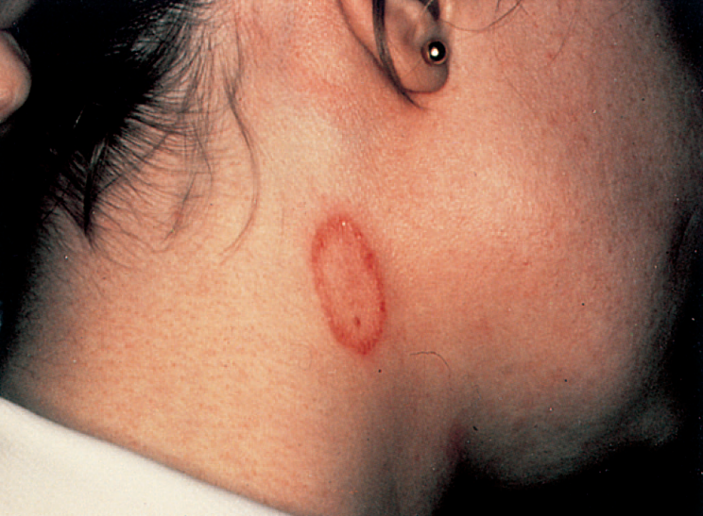
Tinea corporis (ringworm). Note oval, ring-shaped inflamed lesion with central clearing. Caused by dermatophytes such as Epidermophyton, Trichophyton, and Microsporum

Tinea Versicolor
Tinea versicolor (pityriasis versicolor), a superficial skin infection of cosmetic importance only, is caused by Malassezia species. The lesions are usually noticed as hypopigmented areas, especially on tanned skin in the summer. There may be slight scaling or itching, but usually the infection is asymptomatic. It occurs more frequently in hot, humid weather. The lesions contain both budding yeast cells and hyphae. Diagnosis is usually made by observing this mixture in KOH preparations of skin scrapings. Culture is not usually done. The treatment of choice is topical miconazole, but the lesions have a tendency to recur. Oral antifungal drugs, such as fluconazole or itraconazole, can be used to treat recurrences.
Tinea Nigra
Tinea nigra is an infection of the keratinized layers of the skin. It appears as a brownish spot caused by the melaninlike pigment in the hyphae. The causative organism, Cladosporium werneckii, is found in the soil and transmitted during injury. In the United States, the disease is seen in the southern states. Diagnosis is made by microscopic examination and culture of skin scrapings. The infection is treated with a topical keratolytic agent (e.g., salicylic acid).
SUBCUTANEOUS MYCOSES
These are caused by fungi that grow in soil and on vegetation and are introduced into subcutaneous tissue through trauma.
Sporotrichosis
Sporothrix schenckii is a dimorphic fungus. The mold form lives on plants, and the yeast form occurs in human tissue. When spores of the mold are introduced into the skin, typically by a thorn, it causes a local pustule or ulcer with nodules along the draining lymphatics. The lesions are typically painless, and there is little systemic illness. Untreated lesions may wax and wane for years.
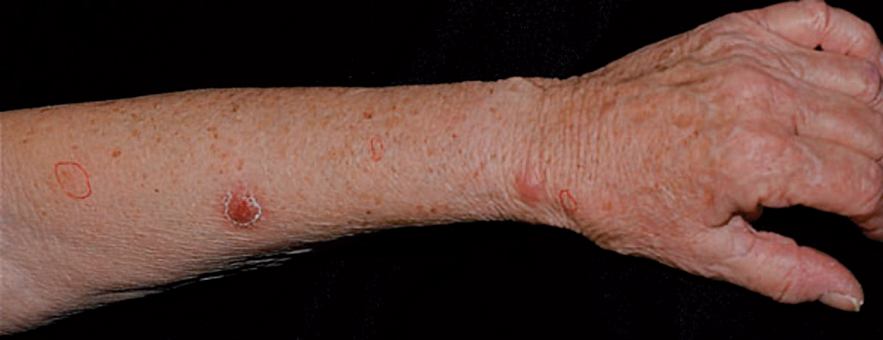
Sporotrichosis. Note papular lesions on left hand and forearm. Caused by Sporothrix schenckii

In human immunodeficiency virus (HIV)–infected patients with low CD4 counts, disseminated sporotrichosis can occur. Sporotrichosis occurs most often in gardeners, especially those who prune roses, because they may be stuck by a rose thorn. In the clinical laboratory, round or cigar-shaped budding yeasts are seen in tissue specimens. In culture at room temperature, hyphae occur bearing oval conidia in clusters at the tip of slender conidiophores (resembling a daisy). The drug of choice for skin lesions is itraconazole (Sporanox). It can be prevented by protecting skin when touching plants, moss, and wood.
Chromomycosis
This is a slowly progressive granulomatous infection that is caused by several soil fungi (Fonsecaea, Phialophora, Cladosporium, etc.) when introduced into the skin through trauma. These fungi are collectively called dematiaceous fungi, so named because their conidia or hyphae are darkcolored, either gray or black. Wartlike lesions with crusting abscesses extend along the lymphatics. The disease occurs mainly in the tropics and is found on bare feet and legs. In the clinical laboratory, dark brown, round fungal cells are seen in leukocytes or giant cells. The disease is treated with oral flucytosine or thiabendazole, plus local surgery.
Mycetoma
Soil fungi (Petriellidium, Madurella) enter through wounds on the feet, hands, or back and cause abscesses, with pus discharged through sinuses. The pus contains compact colored granules. Actinomycetes such as Nocardia can cause similar lesions (actinomycotic mycetoma). Sulfonamides may help the actinomycotic form. There is no effective drug against the fungal form; surgical excision is recommended.

SYSTEMIC MYCOSES
These infections result from inhalation of the spores of dimorphic fungi that have their mold forms in the soil. Within the lungs, the spores differentiate into yeasts or other specialized forms, such as spherules. Most lung infections are asymptomatic and self-limited. However, in some persons, disseminated disease develops in which the organisms grow in other organs, cause destructive lesions, and may result in death. Infected persons do not communicate these diseases to others.
COCCIDIOIDES
Disease
Coccidioides immitis causes coccidioidomycosis.
Properties
Coccodioides immitis is a dimorphic fungus that exists as a mold in soil and as a spherule in tissue.
Transmission & Epidemiology
The fungus is endemic in arid regions of the southwestern United States and Latin America. People who live in Central and Southern California, Arizona, New Mexico, Western Texas, and Northern Mexico, a geographic region called the Lower Sonoran Life Zone, are often infected. In soil, it forms hyphae with alternating arthrospores and empty cells. Arthrospores are very light and are carried by the wind. They can be inhaled and infect the lungs.
Pathogenesis
In the lungs, arthrospores form spherules that are large (30 mm in diameter), have a thick, doubly refractive wall, and are filled with endospores. Upon rupture of the wall, endospores are released and differentiate to form new spherules. The organism can spread within a person by direct extension or via the bloodstream. Granulomatous lesions can occur in virtually any organ but are found primarily in bones and the central nervous system (meningitis). Dissemination from the lungs to other organs occurs in people who have a defect in cell-mediated immunity. Most people who are infected by C. immitis develop a cellmediated (delayed hypersensitivity) immune response that restricts the growth of the organism. One way to determine whether a person has produced adequate cell-mediated immunity to the organism is to do a skin test (see later). Ingeneral, a person who has a positive skin test reaction has developed sufficient immunity to prevent disseminated disease from occurring. If, at a later time, a person’s cellular immunity is suppressed by drugs or disease, disseminated disease can occur.
Clinical Findings
Infection of the lungs is often asymptomatic and is evident only by a positive skin test and the presence of antibodies. Some infected persons have an influenza-like illness with fever and cough. About 50% have changes in the lungs (infiltrates, adenopathy, or effusions) as seen on chestX-ray, and 10% develop erythema nodosum (see later) or arthralgias. This syndrome is called “valley fever” (in the San Joaquin Valley of California) or “desert rheumatism” (in Arizona); it tends to subside spontaneously. Disseminated disease can occur in almost any organ; the meninges (meningitis), bone (osteomyelitis), and skin(nodules) are important sites. The overall incidence of dissemination in persons infected with C. immitis is 1%, although the incidence in Filipinos and African Americans is 10 times higher. Women in the third trimester of pregnancy also have a markedly increased incidence of dissemination. Erythema nodosum (EN) manifests as red, tender nodules (“desert bumps”) on extensor surfaces such as the skin over the tibia and ulna. It is a delayed (cell-mediated) hypersensitivity response to fungal antigens and thus is an indicator of a good prognosis. There are no organisms in these lesions; they are not a sign of disseminated disease.
Laboratory Diagnosis
In tissue specimens, spherules are seen microscopically. Cultures on Sabouraud’s agar incubated at 25°C show septate hyphae with arthrospores . (Caution: Cultures are highly infectious; precautions against inhaling arthrospores must be taken.) In serologic tests, IgM and IgG precipitins appear within 2 to 4 weeks of infection and then decline in subsequent months. Complement-fixing antibodies occur at low titer initially, but the titer rises greatly if dissemination occurs. A PCR assay that detects nucleic acids of Coccidioides is available.
Treatment & Prevention
No treatment is needed in asymptomatic or mild primary infection. Amphotericin B (Fungizone) or itraconazole is used for persisting lung lesions or disseminated disease. Fluconazole is also effective in lung disease. If meningitis occurs, fluconazole is the drug of choice. Intrathecal amphotericin B may be required and may induce remission, but long-term results are often poor. There are no means of prevention except avoiding travel to endemic areas. Patients who have recovered from coccidioidal meningitis should receive long-term suppressive therapy with fluconazole to prevent a recurrence.
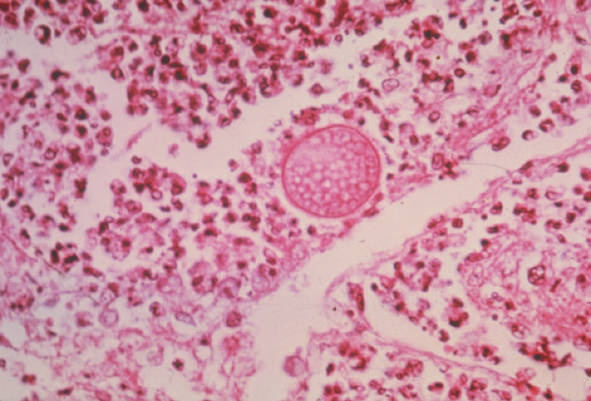
Coccidioides immitis—spherule. Long arrow points to a spherule in lung tissue. Spherules are large thick-walled structures containing many endospores. Short arrow points to an endospore
HISTOPLASMA
Histoplasma capsulatum causes histoplasmosis.
Properties
Histoplasma capsulatum is a dimorphic fungus that exists as a mold in soil and as a yeast in tissue. It forms two types of asexual spores (Figure 49–4): (1) tuberculate macroconidia, with typical thick walls and fingerlike projections that are important in laboratory identification; and (2) microconidia, which are smaller, thin, smooth-walled pores that, if inhaled, transmit the infection.
Transmission & Epidemiology
This fungus occurs in many parts of the world. In them United States, it is endemic in central and eastern states, especially in the Ohio and Mississippi River valleys. It grows in soil, particularly if the soil is heavily contaminated with bird droppings, especially from starlings. Although the birds are not infected, bats can be infected and can excrete the organism in their guano. In areas of endemic infection, excavation of the soil during construction or exploration of bat-infested caves has resulted in a significant number of infected individuals.
Pathogenesis & Clinical Findings
Inhaled spores are engulfed by macrophages and develop into yeast forms. In tissues, H. capsulatum occurs as an oval budding yeast inside macrophages . The yeasts survive within the phagolysosome of the macrophage by producing alkaline substances, such as bicarbonate and ammonia, which raise the pH and thereby inactivate the degradative enzymes of the phagolysosome. The organisms spread widely throughout the body, especially to the liver and spleen, but most infections remain asymptomatic, and the small granulomatous foci heal by calcification. With intense exposure (e.g., in a chicken house or bat-infested cave), pneumonia and cavitary lung lesions may become clinically manifest. Severe disseminated histoplasmosis develops in a small minority of infected persons, especially infants and individuals with reduced cell-mediated immunity, such as patients with acquired immunodeficiency syndrome (AIDS). In AIDS patients, pancytopenia and ulcerated lesions on the tongue are typical of disseminated histoplasmosis. In immunocompetent people, EN can occur (see description of EN in earlier section on Coccidioides). EN is a sign that cellmediated immunity is active and the organism will probably be contained. A skin test using histoplasmin (a mycelial extract) becomes positive (i.e., shows at least 5 mm of induration) within 2 to 3 weeks after infection and remains positive for many years. However, because there are many false-positive reactions (due to cross-reactivity) and many false-negative reactions (in disseminated disease), the skin test is not useful for diagnosis. Furthermore, the skin test can stimulate an antibody response and confuse the serologic tests. The skin test is useful for epidemiologic studies, and up to 90% of individuals have positive results in areas of endemic Infection.
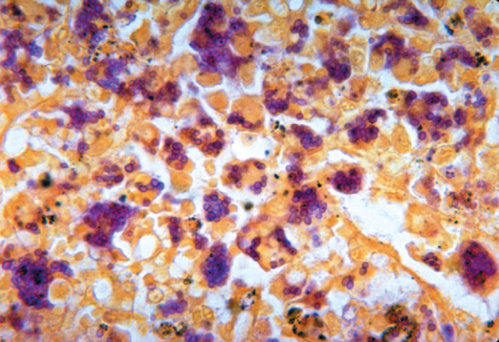
Histoplasma capsulatum—yeasts within macrophages.
Laboratory Diagnosis
In tissue biopsy specimens or bone marrow aspirates, oval yeast cells within macrophages are seen microscopically. Cultures on Sabouraud’s agar show hyphae with tuberculate macroconidia when grown at low temperature (e.g., 25°C) and yeasts when grown at 37°C. Tests that detect a Histoplasma polysaccharide antigen by enzyme-linked immunosorbent assay (ELISA) and Histoplasma RNA with DNA probes are also useful. In immunocompromised patients with disseminated disease, tests for Histoplasma antigen in the urine are especially useful because antibody tests may be negative.
Treatment & Prevention
No therapy is needed in asymptomatic or mild primary infections. With progressive lung lesions, oral itraconazole is effective. In disseminated disease, parenteral itraconazole (or amphotericin B) is the treatment of choice. Liposomal amphotericin B should be used in patients with preexisting kidney damage. In meningitis, fluconazole is often used because it penetrates the spinal fluid well. Oral itraconazole is used for chronic suppression in patients with AIDS.

BLASTOMYCES
Blastomyces dermatitidis causes blastomycosis, also known
as North American blastomycosis.
Properties
Blastomyces dermatitidis is a dimorphic fungus that exists as a mold in soil and as a yeast in tissue. The yeast is round with a doubly refractive wall and a single broad-based bud. Note that this organism forms a broad-based bud, whereas Cryptococcus neoformans is a yeast that forms a narrow-based bud.
Transmission & Epidemiology
This fungus is endemic primarily in eastern North America, especially in the region bordering the Ohio, Mississippi, and St. Lawrence rivers, and the Great Lakes region. Less commonly, blastomycosis has also occurred in Central and South America, Africa, and the Middle East. It grows in moist soil rich in organic material, forming hyphae with small pear-shaped conidia. Inhalation of the conidia causes human infection.
Pathogenesis & Clinical Findings
Infection occurs mainly via the respiratory tract. Asymptomatic or mild cases are rarely recognized. Dissemination may result in ulcerated granulomas of skin, bone, or other sites.
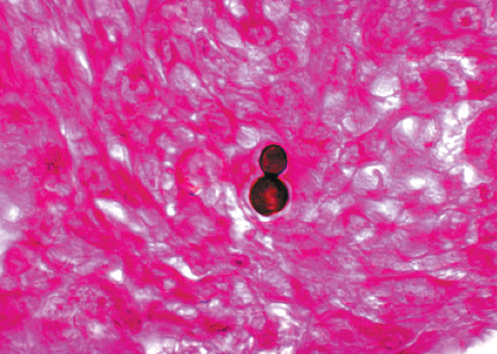
Laboratory Diagnosis
In tissue biopsy specimens, thick-walled yeast cells with single broad-based buds are seen microscopically/ Hyphae with small pear-shaped conidia are visible on culture. The skin test lacks specificity and has little value. Serologic tests have little value. A PCR assay that detects nucleic acids of Blastomyces is available.
Treatment & Prevention
Itraconazole is the drug of choice for most patients, but amphotericin B should be used to treat severe disease. Surgical excision may be helpful. There are no means of prevention.
PARACOCCIDIOIDES
Disease
Paracoccidioides brasiliensis causes paracoccidioidomycosis, also known as South American blastomycosis.
Properties
Paracoccidioides brasiliensis is a dimorphic fungus that exists as a mold in soil and as a yeast in tissue. The yeast is thick-walled with multiple buds, in contrast to B. dermatitidis, which has a single bud .
Transmission & Epidemiology
This fungus grows in the soil and is endemic in rural Latin America. Disease occurs only in that region.
Pathogenesis & Clinical Findings
The spores are inhaled, and early lesions occur in the lungs. Asymptomatic infection is common. Alternatively, oral mucous membrane lesions, lymph node enlargement, and sometimes dissemination to many organs develop.
Laboratory Diagnosis
In pus or tissues, yeast cells with multiple buds resembling a “ship captain’s wheel” are seen microscopically. A specimen cultured for 2 to 4 weeks may grow typical organisms. Skin tests are rarely helpful. Serologic testing shows that when significant antibody titers (by ID or CF) are found, active disease is present.
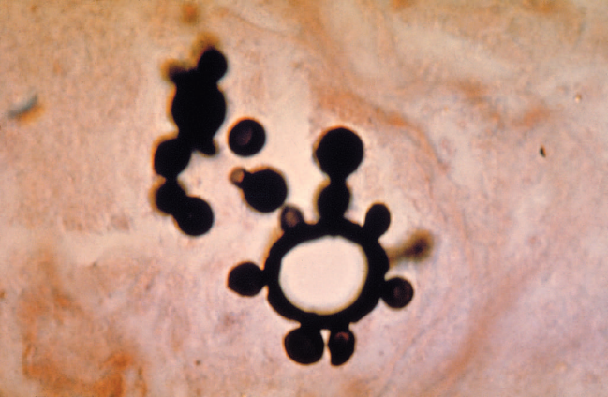
Paracoccidioides—yeasts with multiple buds resembling a “ship captain’s wheel.” Methenamine silver stain.

Treatment & Prevention
The drug of choice is itraconazole taken orally for several months. There are no means of prevention
OPPORTUNISTIC MYCOSES
Opportunistic fungi fail to induce disease in most immunocompetent persons but can do so in those with impaired host defenses. There are five genera of medically important fungi: Candida, Cryptococcus, Aspergillus, Mucor, and Rhizopus.
CANDIDA
Diseases
Candida albicans, the most important species of Candida, causes thrush, vaginitis, esophagitis, diaper rash, and chronic mucocutaneous candidiasis. It also causes disseminated infections such as right-sided endocarditis (especially in intravenous drug users), bloodstream infections (candidemia), and endophthalmitis. Infections related to indwelling intravenous and urinary catheters are also important. Candida glabrata is the second most common cause of disseminated candidal infections and is more drug resistant than C. albicans.
Properties
Candida albicans is an oval yeast with a single bud. It is part of the normal flora of mucous membranes of the upper respiratory, gastrointestinal, and female genital tracts. In tissues it appears most often as yeasts or as pseudohyphae. Pseudohyphae are elongated yeasts that visually resemble hyphae but are not true hyphae. True hyphae are also formed when C. albicans invades tissues. Carbohydrate fermentation reactions can be used to differentiate it from other species (e.g., Candida tropicalis, Candida parapsilosis, Candida krusei, and C. glabrata) that cause human infections. Candida dubliniensis is closely related to C. albicans. It also causes opportunistic infections in immunocompromised patients, especially AIDS patients. Both species form chlamydospores but C. albicans grows at 42°C whereas C. dubliniensis does not.
Transmission
As a member of the normal flora, C. albicans is already present on the skin and mucous membranes. In addition to the skin, C. albicans is found throughout the GI tract (especially the mouth and esophagus) and in the vagina. Thrush in the newborn is the result of passage through a birth canal heavily colonized by the organism. The presence of C. albicans on the skin predisposes to infections involving instruments that penetrate the skin, such as needles (intravenous drug use) and indwelling catheters. It is often found in the urine of patients with indwelling urinary (Foley) catheters.
Pathogenesis & Clinical Findings
The first line of defense against Candida infections is intact skin and mucous membranes. The second line is cellmediated immunity, especially Th-1 cells producing gamma-interferon that activates efficient killing by macrophages. Neutrophils are also important as evidenced by the finding that neutropenia predisposes to disseminated Candida infections. When local or systemic host defenses are impaired, disease may result. Overgrowth of C. albicans in the mouth produces white patches called thrush. Vaginitis with itching and discharge is favored by high pH, diabetes, or use of antibiotics. Antibiotics suppress the normal flora Lactobacillus, which keep the pH low. As a result, the pH rises, which favors the growth of Candida. Skin invasion occurs in warm, moist areas, which become red and weeping. Fingers and nails become involved when repeatedly immersed in water; persons employed as dishwashers in restaurants are commonly affected. Thickening or loss of the nail can occur. Diaper rash in infants occurs when wet diapers are not changed promptly . In immunosuppressed individuals, Candida may disseminate to many organs or cause chronic mucocutaneous candidiasis (CMC). CMC is a prolonged infection of the skin, oral and genital mucosa, and nails that occurs in individuals deficient in T-cell immunity. 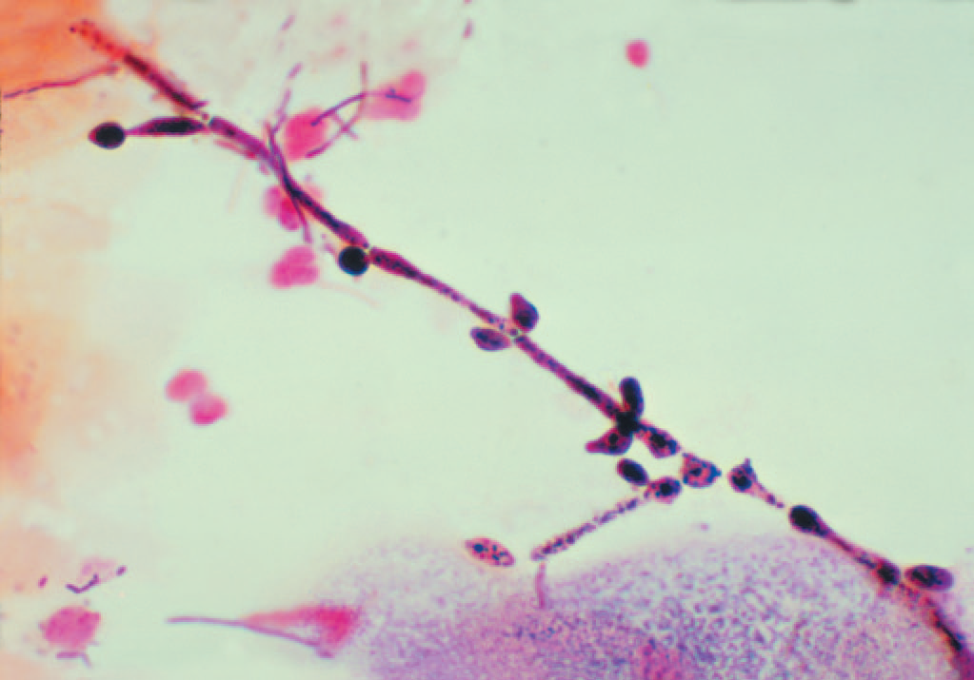
Candida albicans—pseudohyphae
Laboratory Diagnosis
In exudates or tissues, budding yeasts and pseudohyphae appear gram-positive and can be visualized by using calcofluor-white staining. In culture, typical yeast colonies are formed that resemble large staphylococcal colonies. Candida albicans forms germ tubes in serum at 37°C, whereas most other species of pathogenic Candida species do not . Chlamydospores are typically formed by C. albicans but not by most other species of Candida. Note that C. dubliniensis also forms chlamydospores but will not grow at 42°C whereas C. albicans will. Serologic testing is rarely helpful. A laboratory test that can identify C. albicans and four other Candida species in blood cultures in 3 to 5 hours instead of the usual several days was approved in 2014. The test uses magnetic resonance technology to detect the presence of yeast DNA and then to identify the species. Skin tests with Candida antigens are uniformly positive in immunocompetent adults and are used as an indicator that the person can mount a cellular immune response. A person who does not respond to Candida antigens in the skin test is presumed to have deficient cell-mediated immunity. Such a person is anergic, and other skin tests cannot be interpreted. Thus if a person has a negative Candida skin test, a negative purified protein derivative (PPD) skin test for tuberculosis could be a false-negative result.
Treatment & Prevention
The drug of choice for most candidal infections is fluconazole, including oropharyngeal or esophageal thrush. Itraconazole and voriconazole are also effective. An echinocandin, such as caspofungin or micafungin can also be used for esophageal candidiasis. Treatment of skin infections consists of topical antifungal drugs (e.g., clotrimazole or nystatin). Candida vaginitis is treated either with topical (intravaginal) azole drugs, such as clotrimazole or miconazole, or with oral fluconazole. Chronic mucocutaneous candidiasis can be controlled by fluconazole or itraconazole. Treatment of disseminated candidiasis consists of either fluconazole or an echinocandin such as caspofungin. Treatment of candidal infections with antifungal drugs should be supplemented by reduction of predisposing factors. Strains of C. albicans resistant to azole drugs have emerged in patients with acquired immunodeficiency syndrome (AIDS) receiving long-term prophylaxis with fluconazole. Most isolates of C. glabrata are resistant to fluconazole and voriconaziole. An echinocandin such as caspofungin or amphoptericin B should be used. Certain candidal infections (e.g., thrush) can be prevented by oral clotrimazole troches, buccal miconazole tablets, or nystatin “swish and swallow.” Fluconazole is useful in preventing candidal infections in high-risk patients, such as those undergoing bone marrow transplantation and premature infants. Micafungin can also be used. There is no vaccine.
CRYPTOCOCCUS
Disease
Cryptococcus neoformans causes cryptococcosis, especially cryptococcal meningitis. Cryptococcosis is the most common, life-threatening invasive fungal disease worldwide. It is especially important in AIDS patients. Another species, Cryptococcus gattii, causes human disease less frequently than C. neoformans.
Properties
Cryptococcus neoformans is an oval, budding yeast surrounded by a wide polysaccharide capsule . It is not dimorphic. Note that this organism forms a narrow-based bud, whereas the yeast form of Blastomyces dermatitidis forms a broad-based bud.
Transmission
Cryptococcus neoformans occurs widely in nature and grows abundantly in soil containing bird (especially pigeon) droppings. The birds are not infected. Human infection results from inhalation of the organism. There is no human-to-human transmission. Cryptococcus gattii is associated with eucalyptus trees, most often in the northwestern states of the United States. It is also found in subtropical and tropical areas of many countries.
Pathogenesis & Clinical Findings
Lung infection is often asymptomatic or may produce pneumonia. Disease caused by C. neoformans occurs mainly in patients with reduced cell-mediated immunity, especially AIDS patients, in whom the organism disseminates to the central nervous system (meningitis) and other organs. Subcutaneous nodules are often seen in disseminated disease. Note, however, that roughly half the patients with cryptococcal meningitis fail to show evidence of immunosuppression. In some patients with AIDS who are infected with Cryptococcus, treating the patient with highly active antiretroviral therapy (HAART) causes an exacerbation of symptoms.
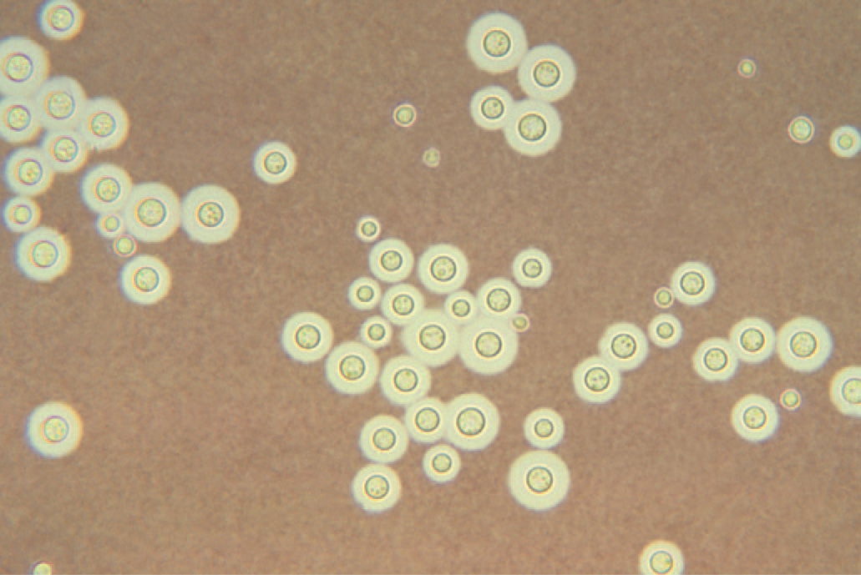
Cryptococcus neoformans—India ink preparation.

Laboratory Diagnosis
In spinal fluid mixed with India ink, the yeast cell is seen microscopically surrounded by a wide, unstained capsule. Appearance of the organism in Gram stain is unreliable,but stains such as periodic acid–Schiff (PAS stain), methenaminemsilver, and mucicarmine will allow the organism to be visualized . The organism can be cultured from spinal fluid and other specimens. The colonies are highly mucoid—a reflection of the large amount of capsular polysaccharide produced by the organism. Serologic tests can be done for both antibody and antigen. In infected spinal fluid, capsular antigen occurs in high titer and can be detected by the latex particle agglutination test. This test is called the cryptococcal antigen test, often abbreviated as “crag.” Distinguishing between C. neoformans and C. gattii in the laboratory requires specialized media not generally available, so many C. gattii infections may go undiagnosed.
Treatment & Prevention
Combined treatment with amphotericin B and flucytosine is used in meningitis and other disseminated disease. Liposomal amphotericin B should be used in patients with preexisting kidney damage. There are no specific means of prevention. Fluconazole is used in AIDS patients for longterm suppression of cryptococcal meningitis. Cryptococcus gattii is less responsive to antifungal drugs than is C. neoformans.
ASPERGILLUS
Disease
Aspergillus species, especially Aspergillus fumigatus, cause infections of the skin, eyes, ears, and other organs; “fungus ball” in the lungs; and allergic bronchopulmonary aspergillosis.
Properties
Aspergillus species exist only as molds; they are not dimorphic. They have septate hyphae that form V-shaped (dichotomous) branches . The walls are more or less parallel, in contrast to Mucor and Rhizopus walls, which are irregular . The conidia of Aspergillus form radiating chains, in contrast to those of Mucor and Rhizopus, which are enclosed within a sporangium.
Transmission
These molds are widely distributed in nature. They grow on decaying vegetation, producing chains of conidia. Transmission is by airborne conidia.
Pathogenesis & Clinical Findings
Aspergillus fumigatus can colonize and later invade abraded skin, wounds, burns, the cornea, the external ear, or paranasal sinuses. It is the most common cause of fungal sinusitis. In immunocompromised persons, especially those with neutropenia, it can invade the lungs producing hemoptysis and the brain causing an abscess. Neutropenic patients are also predisposed to intravenous catheter infections caused by this organism. In 2012, an outbreak of A. fumigatus infections, especially meningitis, occurred caused by injectable corticosteroid solutions that were contaminated with the fungus. Aspergilli are well-known for their ability to grow in cavities within the lungs, especially cavities caused by tuberculosis. Within the cavities, they produce an aspergilloma (fungus ball), which can be seen on chest X-ray as a radiopaque structure that changes its position when the patient is moved from an erect to a supine position. Allergic bronchopulmonary aspergillosis (ABPA) is a hypersensitivity reaction to the presence of Aspergillus in the bronchi. Patients with ABPA have asthmatic symptoms and a high IgE titer against Aspergillus antigens, and they expectorate brownish bronchial plugs containing hyphae. Asthma caused by the inhalation of airborne conidia, especially in certain occupational settings, also occurs. Aspergillus flavus growing on cereals or nuts produces aflatoxins that may be carcinogenic or acutely toxic.
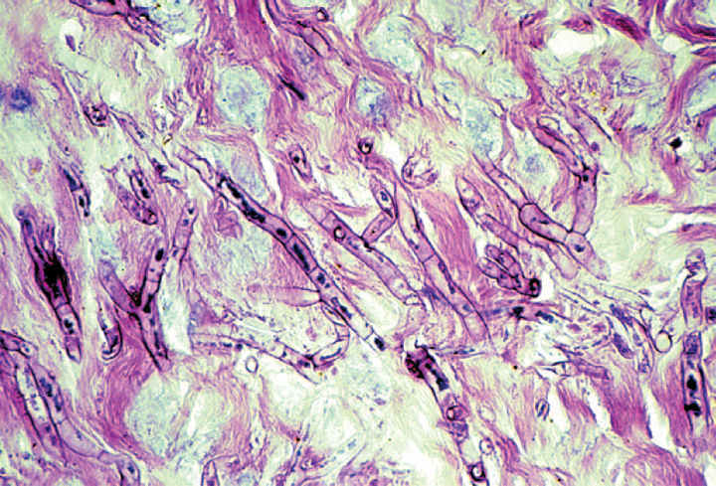
Laboratory Diagnosis
Biopsy specimens show septate, branching hyphae invading tissue . Cultures show colonies with characteristic radiating chains of conidia . However, positive cultures do not prove disease because colonization is common. In persons with invasive aspergillosis, there may be high titers of galactomannan antigen in serum. Patients with ABPA have high levels of IgE specific for Aspergillus antigens and prominent eosinophilia. IgG precipitins are also present.
Treatment & Prevention
Voriconazole is the drug of choice for invasive aspergillosis. Liposomal amphotericin B, posaconazole, and caspofungin are alternative drugs. A fungus ball growing in a sinus or in a pulmonary cavity can be surgically removed. Patients with ABPA can be treated with corticosteroids and antifungal agents, such as itraconazole. There are no specific means of prevention.
MUCOR & RHIZOPUS
Mucormycosis (zygomycosis, phycomycosis) is a disease caused by saprophytic molds (e.g., Mucor, Rhizopus, and Absidia) found widely in the environment. They are not dimorphic. These organisms are transmitted by airborne asexual spores and invade tissues of patients with reduced host defenses. They proliferate in the walls of blood vessels, particularly of the paranasal sinuses, lungs, or gut, and cause infarction and necrosis of tissue distal to the blocked vessel . Patients with diabetic ketoacidosis, burns, bone marrow transplants, or leukemia are particularly susceptible. Diabetic patients are particularly susceptible to rhinocerebral mucormycosis, in which mold spores in the sinuses germinate to form hyphae that invade blood vessels that supply the brain. One species, Rhizopus oryzae, causes about 60% of cases of mucormycosis. In biopsy specimens, organisms are seen microscopically as nonseptate hyphae with broad, irregular walls and branches that form more or less at right angles . Cultures show colonies with spores contained within a sporangium. These organisms are difficult to culture because they are a single, very long cell, and damage to any part of the cell can limit its ability to grow. If diagnosis is made early, treatment of the underlying disorder, plus administration of amphotericin B and surgical removal of necrotic infected tissue, has resulted in some remissions and cures. Liposomal amphotericin B should be used in patients with preexisting kidney damage. Posaconazole can also be used.
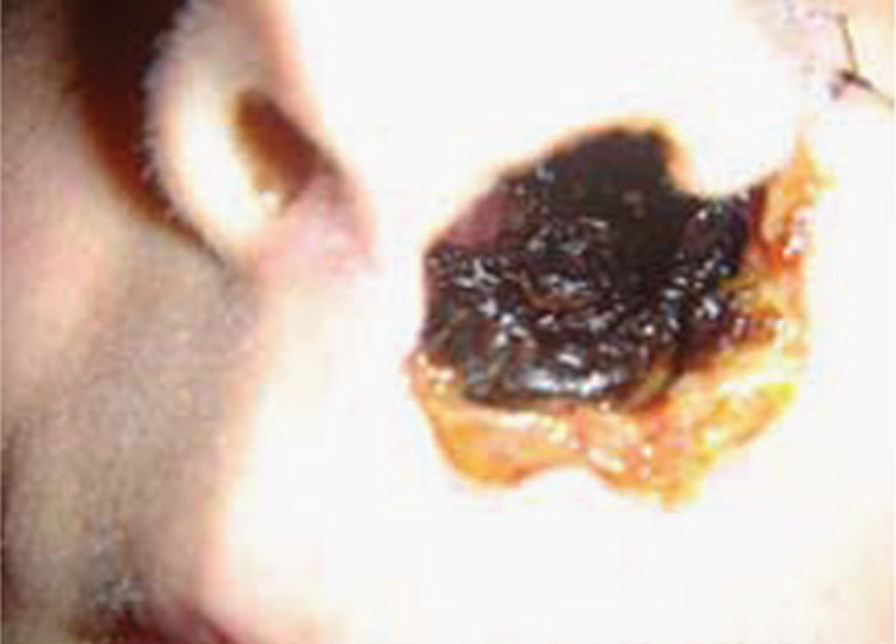

Mucor species—mucormycosis. Note necrotic area involving the nose and face

PNEUMOCYSTIS
Pneumocystis jiroveci is classified as a yeast on the basis of molecular analysis, but it has many characteristics of a protozoan. Some regard it as an “unclassified” organism.In 2002, taxonomists renamed the human species of Pneumocystis as P. jiroveci and recommended that P. carinii be used only to describe the rat species of Pneumocystis. Pneumocystis is acquired by inhalation of airborne organisms into the lungs. An inflammatory exudate composed primarily of plasma cells occurs, oxygen exchange is reduced, and dyspnea occurs. A reduced number of CD 4-postive T lymphocytes, such as occurs in AIDS, predisposes to pneumonia. Most immunocompetent people have asymptomatic infections. The clinical findings of Pneumocystis pneumonia include fever, nonproductive cough, and dyspnea. Rales are heard bilaterally and the chest X-ray shows a “groundglass” pattern. The mortality rate of untreated Pneumocystis pneumonia is approximately 100%.

Parasitology
Parasites occur in two distinct forms: single-celled protozoa and multicellular metazoa called helminths or worms. For medical purposes, protozoa can be subdivided into four groups: Sarcodina (amebas), Sporozoa (sporozoans), Mastigophora (flagellates), and Ciliata (ciliates). Metazoa are subdivided into two phyla: the Platyhelminthes (flatworms) and the Nemathelminthes (roundworms, nematodes). The phylum Platyhelminthes contains two medically important classes: Cestoda (tapeworms) and Trematoda (flukes).
INTESTINAL PROTOZOA
ENTAMOEBA
Entamoeba histolytica causes amebic dysentery and liver abscess.
Important Properties
The life cycle has two stages: the motile ameba (trophozoite) and the nonmotile cyst . The trophozoite is found within the intestinal and extraintestinal lesions and in diarrheal stools. The cyst predominates in nondiarrheal stools. These cysts are not highly resistant and are readily killed by boiling but not by chlorination ofwater supplies. They are removed by filtration of water. The cyst has four nuclei, an important diagnostic criterion. Upon excystation in the intestinal tract, an ameba with four nuclei emerges and then divides to form eight trophozoites. The mature trophozoite has a single nucleus with an even lining of peripheral chromatin and a prominent central nucleolus (karyosome). Antibodies are formed against trophozoite antigens in
invasive amebiasis, but they are not protective; previous infection does not prevent reinfection. The antibodies are useful, however, for serologic diagnosis.
Pathogenesis & Epidemiology
The organism is acquired by ingestion of cysts that are transmitted primarily by the fecal–oral route in contaminated food and water. Anal–oral transmission (e.g., among male homosexuals) also occurs. There is no animal reservoir. The ingested cysts differentiate into trophozoites in the ileum but tend to colonize the cecum and colon. The trophozoites invade the colonic epithelium and secrete enzymes that cause localized necrosis. Little inflammation occurs at the site. As the lesion reaches the muscularis layer, a typical “flask-shaped” ulcer forms that can undermine and destroy large areas of the intestinal epithelium. Progression into the submucosa leads to invasion of the portal circulation by the trophozoites. By far the most frequent site of systemic disease is the liver, where abscesses containing trophozoites form.
Clinical Findings
Acute intestinal amebiasis presents as dysentery (i.e., bloody, mucus-containing diarrhea) accompanied by lower abdominal discomfort, flatulence, and tenesmus. Chronic amebiasis with low-grade symptoms such as occasional diarrhea, weight loss, and fatigue also occurs. Roughly 90% of those infected have asymptomatic infections, but they may be carriers, whose feces contain cysts that can be transmitted to others. In some patients, a granulomatous lesion called an ameboma may form in the cecal or rectosigmoid areas of the colon. These lesions can resemble an adenocarcinoma of the colon and must be distinguished from them. Amebic abscess of the liver is characterized by rightupper- quadrant pain, weight loss, fever, and a tender, enlarged liver. Right-lobe abscesses can penetrate the diaphragm and cause lung disease. Most cases of amebic liver abscess occur in patients who have not had overt intestinal amebiasis. Aspiration of the liver abscess yields brownish-yellow pus with the appearance and consistency of anchovy paste.
Laboratory Diagnosis
Diagnosis of intestinal amebiasis rests on finding either trophozoites in diarrheal stools or cysts in formed stools. Diarrheal stools should be examined within 1 hour of collection to see the ameboid motility of the trophozoite. Trophozoites characteristically contain ingested red blood cells. The most common error is to mistake fecal leukocytes for trophozoites. Because cysts are passed intermittently, at least three specimens should be examined. The O&P test is insensitive and false negatives commonly occur. Also, about half of the patients with extraintestinal amebiasis have negative stool examinations. Entamoeba histolytica can be distinguished from other amebas by two major criteria: (1) The first is the nature of the nucleus of the trophozoite. The E. histolytica nucleus has a small central nucleolus and fine chromatin granules along the border of the nuclear membrane. The nuclei of other amebas are quite different. (2) The second is cyst size and number of its nuclei. Mature cysts of E. histolytica are smaller than those of Entamoeba coli and contain four nuclei, whereas E. coli cysts have eight nuclei. The trophozoites of Entamoeba dispar, a nonpathogenic species of Entamoeba, are morphologically indistinguishable from those of E. histolytica; therefore, a person who has trophozoites in the stool is only treated if symptoms warrant it. Two tests are highly specific for E. histolytica in the stool: one detects E. histolytica antigen, and the other detects nucleic acids of the organism in a polymerase chain reaction (PCR)-based assay.

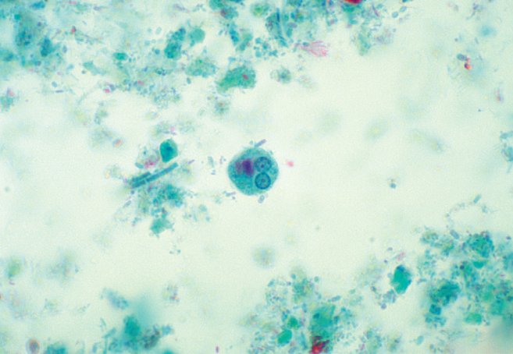
Entamoeba histolytica—cyst. Arrow points to a cyst of E. histolytica. Two of the four nuclei are visible just to the left of the head of the arrow.
Treatment
The treatment of choice for symptomatic intestinal amebiasis or hepatic abscesses is metronidazole (Flagyl) or tinidazole. Hepatic abscesses need not be drained. Asymptomatic cyst carriers should be treated with iodoquinol or paromomycin.
Prevention
Prevention involves avoiding fecal contamination of food and water and observing good personal hygiene such as handwashing. Purification of municipal water supplies is usually effective, but outbreaks of amebiasis in city dwellers still occur when contamination is heavy. The use of “night soil” (human feces) for fertilization of crops should be prohibited. In areas of endemic infection, vegetables should be сooked.
GIARDIA
Giardia lamblia causes giardiasis. The trophozoite is pearshaped with two nuclei, four pairs of flagella, and a suction disk with which it attaches to the intestinal wall. The oval cyst is thick-walled with four nuclei and several internal fibers. Each cyst gives rise to two trophozoites during excystation in the intestinal tract.
Pathogenesis & Epidemiology
Transmission occurs by ingestion of cysts in fecally contaminated food and water. Excystation takes place in the duodenum, where the trophozoite attaches to the gut wall but does not invade the mucosa and does not enter the bloodstream. The trophozoite causes inflammation of the duodenal mucosa, leading to malabsorption of protein and fat. The organism is found worldwide; about 5% of stool specimens in the United States contain Giardia cysts. Approximately half of those infected are asymptomatic carriers who continue to excrete the cysts for years. IgA deficiency greatly predisposes to symptomatic infection.
Clinical Findings
Watery (nonbloody), foul-smelling diarrhea is accompanied by nausea, anorexia, flatulence, and abdominal cramps persisting for weeks or months. There is no fever.
Laboratory Diagnosis
Diagnosis is made by finding trophozoites or cysts or both in diarrheal stools. In formed stools (e.g., in asymptomatic carriers), only cysts are seen. An enzymelinked immunosorbent assay (ELISA) test that detects Giardia antigen in the stool is also very useful. Tests for antibody in the serum are not routinely available. If those tests are negative and symptoms persist, the string test, which consists of swallowing a weighted piece of string until it reaches the duodenum, may be useful. The trophozoites adhere to the string and can be visualized after withdrawal of the string.
Treatment
The treatment of choice is either tinidazole (Tinidamax) or metronidazole (Flagyl). Tinidazole is better tolerated.
Prevention
Prevention involves drinking boiled, filtered, or iodinetreated water in endemic areas and while hiking. No prophylactic drug or vaccine is available.

CRYPTOSPORIDIUM
Disease
Cryptosporidium hominis causes cryptosporidiosis, the main symptom of which is diarrhea. The diarrhea is most severe in immunocompromised patients (e.g., those with acquired immunodeficiency syndrome [AIDS]). Cryptosporidium parvum is the former name that is no longer used.
Important Properties
Some aspects of the life cycle remain uncertain, but the following stages have been identified. Oocysts release sporozoites, which form trophozoites. Several stages ensue, involving the formation of schizonts and merozoites. Eventually microgametes and macrogametes form; these unite to produce a zygote, which differentiates into an oocyst. This cycle has several features in common with other sporozoa (e.g., Isospora). Taxonomically, Cryptosporidium is in the subclass Coccidia.
Pathogenesis & Epidemiology
The organism is acquired by fecal–oral transmission of oocysts from either human sources (primarily) or from animal sources, for example, cattle (occasionally). The oocysts excyst in the small intestine, where the trophozoites (and other forms) attach to the gut wall. Invasion does not occur. The jejunum is the site most heavily infested. The pathogenesis of the diarrhea is uncertain; no toxin has been identified. Cryptosporidia cause diarrhea worldwide. Large outbreaks of diarrhea caused by cryptosporidia in several cities in the United States are attributed to inadequate purification of drinking water. Other outbreaks are related to swimming in fecally contaminated pools and lakes. The cysts are highly resistant to chlorination but are killed by pasteurization and can be removed by filtration.

Clinical Findings
The disease in immunocompromised patients presents primarily as a watery, nonbloody diarrhea causing large fluid loss. Symptoms persist for long periods in immunocompromised patients, whereas they are self-limited in immunocompetent patients. Although immunocompromised patients usually do not die of cryptosporidiosis, the fluid loss and malnutrition are severely debilitating.
Laboratory Diagnosis
Diagnosis is made by finding oocysts in fecal smears when using a modified Kinyoun acid-fast stain. A test for Cryptosporidium antigen in the stool is also useful.
Treatment & Prevention
Nitazoxanide is the drug of choice for patients not infected with human immunodeficiency virus (HIV). There is no effective drug therapy for severely immunocompromised patients, but paromomycin may be useful in reducing diarrhea. There is no vaccine or other specific means of prevention. Purification of the water supply, including filtration to remove the cysts, which are resistant to the chlorine used for disinfection, can prevent cryptosporidiosis

UROGENITAL PROTOZOA TRICHOMONAS
Trichomonas vaginalis causes trichomoniasis.
Important Properties
Trichomonas vaginalis is a pear-shaped organism with a central nucleus and four anterior flagella. It has an undulating membrane that extends about two-thirds of its length. It exists only as a trophozoite; there is no cyst form.
Pathogenesis & Epidemiology
The organism is transmitted by sexual contact, and hence there is no need for a durable cyst form. The primary locations of the organism are the vagina and the prostate. It is found only in humans; there is no animal reservoir. Trichomoniasis is one of the most common infections worldwide. Roughly 25% to 50% of women in the United States harbor the organism. The frequency of symptomatic disease is highest among sexually active women in their thirties and lowest in postmenopausal women. Asymptomatic infections are common in both men and women.
Clinical Findings
In women, a watery, foul-smelling, greenish vaginal discharge accompanied by itching and burning occurs. Infection in men is usually asymptomatic, but about 10% of infected men have urethritis.
Laboratory Diagnosis
In a wet mount of vaginal discharge, the pear-shaped trophozoites have a typical jerky motion .Neutrophils are often seen in the fluid. There is no serologic Test.
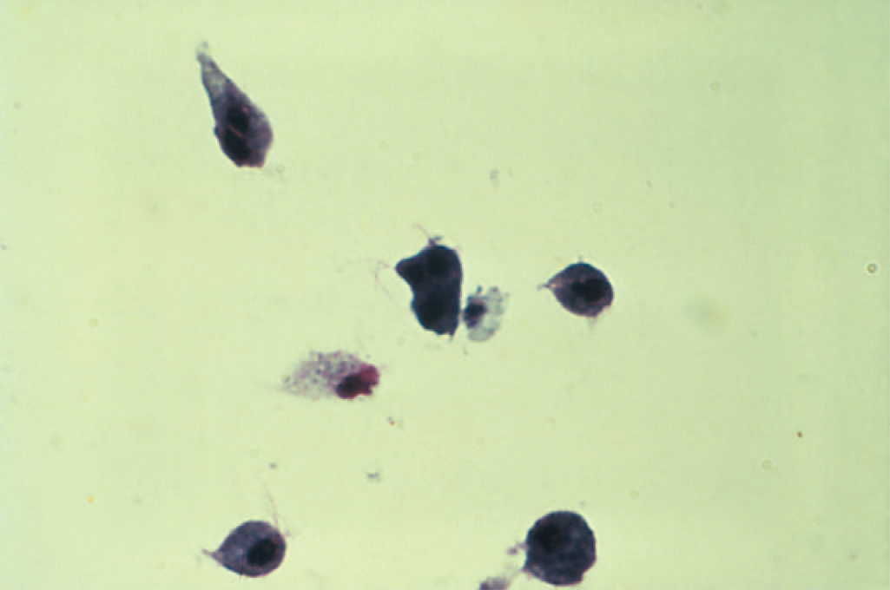
Trichomonas vaginalis

Treatment & Prevention
The treatment of choice is either tinidazole (Tinidamax) or metronidazole (Flagyl) for both partners to prevent reinfection. Tinidazole is better tolerated. Maintenance of the low pH of the vagina is helpful. Condoms limit transmission. No prophylactic drug or vaccine is available.
BLOOD& TISSUE PROTOZOA

PLASMODIUM
Malaria is caused primarily by four plasmodia: Plasmodium vivax, Plasmodium ovale, Plasmodium malariae, and Plasmodium falciparum. Plasmodium vivax and P. falciparum are more common causes of malaria than are P. ovale and P. malariae. Plasmodium vivax is most widely distributed and P. falciparum causes the most serious disease. A fifth species, Plasmodium knowlesi, is found in Southeast Asia. Worldwide, malaria is one of the most common infectious diseases and one of the leading causes of death.
Important Properties
The vector and definitive host for plasmodia is the female Anopheles mosquito (only the female takes a blood meal). There are two phases in the life cycle: the sexual cycle, which occurs primarily in mosquitoes, and the asexual cycle, which occurs in humans, the intermediate hosts.1 The sexual cycle is called sporogony because sporozoites are produced, and the asexual cycle is called schizogony because schizonts are made. The life cycle in humans begins with the introduction of sporozoites into the blood from the saliva of the biting mosquito. The sporozoites are taken up by hepatocytes within 30 minutes. This “exoerythrocytic” phase consists of cell multiplication and differentiation into merozoites. Plasmodium vivax and P. ovale produce a latent form (hypnozoite) in the liver; this form is the cause of relapses seen with vivax and ovale malaria. Merozoites are released from the liver cells and infect red blood cells. During the erythrocytic phase ,the organism differentiates into a ringshaped trophozoite. The sexual cycle begins in the human red blood cells when some merozoites develop into male and others into female gametocytes . The gametocyte-containing red blood cells are ingested by the female Anopheles mosquito and, within her gut, produce a female macrogamete and eight spermlike male microgametes. After fertilization, the diploid zygote differentiates into a motile ookinete that burrows into the gut wall, where it grows into an oocyst within which many haploid sporozoites are produced
Pathogenesis & Epidemiology
Most of the pathologic findings of malaria result from the destruction of red blood cells. Red cells are destroyed both by the release of the merozoites and by the action of the spleen to first sequester the infected red cells and then to lyse them. The enlarged spleen characteristic of malaria is due to congestion of sinusoids with erythrocytes, coupled with hyperplasia of lymphocytes and macrophages. Malaria caused by P. falciparum is more severe than that caused by other plasmodia. It is characterized by infection of far more red cells than the other malarial species and by occlusion of the capillaries with aggregates of parasitized red cells. This leads to life-threatening hemorrhage and necrosis, particularly in the brain (cerebral malaria). Furthermore, extensive hemolysis and kidney damage occur, with resulting hemoglobinuria. The dark color of the patient’s urine has given rise to the term “blackwater fever”. The hemoglobinuria can lead to acute renal failure. The timing of the fever cycle is 72 hours for P. malariae and 48 hours for the other plasmodia. Disease caused by P. malariae is called quartan malaria because it recurs every fourth day, whereas malaria caused by the other plasmodia is called tertian malaria because it recurs every third day. Tertian malaria is subdivided into malignant malaria, caused by P. falciparum, and benign malaria, caused by P. vivax and P. ovale. Plasmodium falciparum causes a high level of parasitemia because it can infect red cells of all ages. In contrast, P. vivax infects only reticulocytes and P. malariae infects only mature red cells; therefore, they produce much lower levels of parasites in the blood. Individuals with sickle cell trait (heterozygotes) are protected against malaria because their red cells have too little ATPase activity and cannot produce sufficient energy to support the growth of the parasite.

Clinical Findings
Malaria presents with abrupt onset of fever and chills, accompanied by headache, myalgias, and arthralgias, about 2 weeks after the mosquito bite. Fever may be continuous early in the disease; the typical periodic cycle does not develop for several days after onset. The fever spike, which can reach 41°C, is frequently accompanied by shaking chills, nausea, vomiting, and abdominal pain. The fever is followed by drenching sweats. Patients usually feel well between the febrile episodes. Splenomegaly is seen in most patients, and hepatomegaly occurs in roughly one-third. Anemia is prominent. Untreated malaria caused by P. falciparum is potentially life-threatening as a result of extensive brain (cerebral malaria) and kidney (blackwater fever) damage. Malaria caused by the other three plasmodia is usually self-limited, with a low mortality rate. However, relapses of P. vivax and P. ovale malaria can occur up to several years after the initial illness as a result of hypnozoites latent in the liver.
Laboratory Diagnosis
Diagnosis rests on microscopic examination of blood, using both thick and thin Giemsa-stained smears. The thick smear is used to screen for the presence of organisms, and the thin smear is used for species identification. It is important to identify the species because the treatment of different species can differ. Ring-shaped trophozoites can be seen within infected red blood cells.The gametocytes of P. falciparum are crescent-shaped (“banana-shaped”), whereas those of the other plasmodia are spherical. If more than 5% of red blood cells are parasitized, the diagnosis is usually P. falciparum malaria. Plasmodium species typically produce hemozoin pigment in infected red blood cells whereas Babesia species do not. Plasmodia metabolize heme in the red cells to produce hemozoin. Also found within P. vivax and P. ovale-infected red cells are Schüffner’s dots. These are intracytoplasmic granules that stain red using the Romanovsky stain. If blood smears do not reveal the diagnosis, then a polymerase chain reaction (PCR)-based test for Plasmodium nucleic acids or an enzyme-linked immunosorbent assay (ELISA) test for a protein specific for P. falciparum can be useful.
Treatment
The main criteria used for choosing specific drugs are the severity of the disease and whether the organism is resistant to chloroquine. Chloroquine resistance is determined by the geographical location where the infection was acquired rather than by laboratory testing. Chloroquine is the drug of choice for treatment of uncomplicated malaria caused by non-falciparum species in areas without chloroquine resistance. Chloroquine kills the merozoites, thereby reducing the parasitemia, but does not affect the hypnozoites of P. vivax and P. ovale in the liver. These are killed by primaquine, which must be used to prevent relapses. Primaquine may induce severe hemolysis in those with G6PD deficiency, so testing for this enzyme should be done before the drug is given. Primaquine should not be given if the patient is severely G6PD deficient. If primaquine is not given, one approach is to wait to see whether symptoms recur and then treat with chloroquine.

Prevention
Chemoprophylaxis of malaria for travelers to areas where chloroquine-resistant P. falciparum is endemic consists of mefloquine or doxycycline. A combination of atovaquone and proguanil (Malarone), in a fixed dose, can also be used. Chloroquine should be used in areas where P. falciparum is sensitive to that drug. Travelers to areas where the other three plasmodia are found should take chloroquine starting 2 weeks before arrival in the endemic area and continuing for 4 weeks after leaving the endemic area. This should be followed by a 2-week course of primaquine if exposure was high. Primaquine will kill the hypnozoites of P. vivax and P. ovale.

TOXOPLASMA
Toxoplasma gondii causes toxoplasmosis, including congenital toxoplasmosis.
Important Properties
The definitive host is the domestic cat and other felines; humans and other mammals are intermediate hosts. Infection of humans begins with the ingestion of cysts in undercooked meat or from accidental contact with cysts in cat feces. In the small intestine, the cysts rupture and release forms that invade the gut wall, where they are ingested by macrophages and differentiate into rapidly multiplying trophozoites (tachyzoites), which kill the cells and infect other cells. Cell-mediated immunity usually limits the spread of tachyzoites, and the parasites enter host cells in the brain, muscle, and other tissues, where they develop into cysts in which the parasites multiply slowly. These forms are called bradyzoites. These tissue cysts are both an important diagnostic feature and a source of organisms when the tissue cyst breaks in an immunocompromised patient. The cycle within the cat begins with the ingestion of cysts in raw meat (e.g., mice). Bradyzoites are released from the cysts in the small intestine, infect the mucosal cells, and differentiate into male and female gametocytes, whose gametes fuse to form oocysts that are excreted in cat feces. The cycle is completed when soil contaminated with cat feces is accidentally ingested. Human infection usually occurs from eating undercooked meat (e.g., lamb and pork) from animals that grazed in soil contaminated with infected cat feces.
Pathogenesis & Epidemiology
Toxoplasma gondii is usually acquired by ingestion of cysts in uncooked meat or in food accidentally contaminated by cat feces. Transplacental transmission from an infected mother to the fetus occurs also. Human-to-human transmission, other than transplacental transmission, does not occur. After infection of the intestinal epithelium, the organisms spread to other organs, especially the brain, lungs, liver, and eyes. Progression of the infection is usually limited by a competent immune system. Cell-mediated immunity plays the major role, but circulating antibody enhances killing of the organism. Most initial infections are asymptomatic. When contained, the organisms persist as cysts within tissues. There is no inflammation, and the individual remains well unless immunosuppression allows activation of organisms in the cysts.Congenital infection of the fetus occurs only when the mother is infected during pregnancy. If she is infected before the pregnancy, the organism will be in the cyst form and there will be no trophozoites to pass through the placenta. The mother who is reinfected during pregnancy but who has immunity from a previous infection will not transmit the organism to her child. Roughly onethird of mothers infected during pregnancy give birth to infected infants, but only 10% of these infants are symptomatic.
Clinical Findings
Most primary infections in immunocompetent adults are asymptomatic, but some resemble infectious mononucleosis, except that the heterophil antibody test is negative. Congenital infection can result in abortion, stillbirth, or neonatal disease with encephalitis, chorioretinitis, and hepatosplenomegaly. Fever, jaundice, and intracranial calcifications are also seen. Most infected newborns are asymptomatic, but chorioretinitis or mental retardation will develop in some children months or years later. Congenital infection with Toxoplasma is one of the leading causes of blindness in children. In patients with reduced cell-mediated immunity (e.g., patients with acquired immunodeficiency syndrome [AIDS]), life-threatening disseminated disease, primarily encephalitis, occurs.
Laboratory Diagnosis
For the diagnosis of acute and congenital infections, an immunofluorescence assay for IgM antibody is used. IgM is used to diagnose congenital infection, because IgG can be maternal in origin. Tests of IgG antibody can be used to diagnose acute infections if a significant rise in antibody titer in paired sera is observed. Microscopic examination of Giemsa-stained preparations shows crescent-shaped trophozoites during acute infections. Cysts may be seen in the tissue. The organism can be grown in cell culture. Inoculation into mice can confirm the diagnosis.
Treatment
Congenital toxoplasmosis, whether symptomatic or asymptomatic, should be treated with a combination of sulfadiazine and pyrimethamine. These drugs also constitute the treatment of choice for disseminated disease in immunocompromised patients. Acute toxoplasmosis in an immunocompetent individual is usually self-limited, but any patient with chorioretinitis should be treated.
Prevention
The most effective means of preventing toxoplasmosis is to cook meat thoroughly to kill the cysts. Pregnant women should be especially careful to avoid undercooked meat and contact with cat feces. They should refrain from emptying cat litter boxes. Cats should not be fed raw meat. Trimethoprim- sulfamethoxazole is used to prevent Toxoplasma encephalitis in patients infected with human immunodeficiency virus (HIV).
PNEUMOCYSTIS
Pneumocystis jiroveci is an important cause of pneumonia in immunocompromised individuals. In 2002, taxonomists renamed the human species of Pneumocystis as P. jiroveci and recommended that Pneumocystis carinii be used only to describe the rat species of Pneumocystis.
Important Properties
The classification and life cycle of Pneumocystis are unclear. Many aspects of its biochemistry indicate that it is a yeast, but it also has several attributes of a protozoan. An analysis of rRNA sequences published in 1988 indicates that Pneumocystis should be classified as a fungus related to yeasts such as Saccharomyces cerevisiae. Subsequent analysis of mitochondrial DNA and of various enzymes supports the idea that it is a fungus. However, it does not have ergosterol in its membranes as do the fungi. It has cholesterol. Medically, it is still thought of as a protozoan. In tissue, it appears as a cyst that resembles the cysts of protozoa. The findings that it does not grow on fungal media and that antifungal drugs are ineffective have delayed acceptance of its classification as a fungus. Pneumocystis species are found in domestic animals such as horses and sheep and in a variety of rodents, but it is thought that these animals are not a reservoir for human infection. Each mammalian species is thought to have its own species of Pneumocystis. Pneumocystis species have a major surface glycoprotein that exhibits significant antigenic variation in a manner similar to that of Trypanosoma brucei. Pneumocystis species have multiple genes encoding these surface proteins, but only one is expressed at a time. This process of programmed rearrangements was first observed in T. brucei.
Pathogenesis & Epidemiology
Transmission occurs by inhalation, and infection is predominantly in the lungs. The presence of cysts in the alveoli induces an inflammatory response consisting primarily of plasma cells, resulting in a frothy exudate that blocks oxygen exchange. (The presence of plasma cells has led to the name “plasma cell pneumonia”.) The organism does not invade the lung tissue. Pneumonia occurs when host defenses (e.g., the number of CD4-positive [helper] T cells) are reduced. This accounts for the prominence of Pneumocystis pneumonia in patients with AIDS and in premature or debilitated infants. Hospital outbreaks do not occur, and patients with Pneumocystis pneumonia are not isolated.
Clinical Findings
The sudden onset of fever, nonproductive cough, dyspnea, and tachypnea is typical of Pneumocystis pneumonia. Bilateral rales and rhonchi are heard, and the chest X-ray shows a diffuse interstitial pneumonia with “ground glass” infiltrates bilaterally. In infants, the disease usually has a more gradual onset. Extrapulmonary Pneumocystis infections occur in the late stages of AIDS and affect primarily the liver, spleen, lymph nodes, and bone marrow. The mortality rate of untreated Pneumocystis pneumonia approaches 100%.
Laboratory Diagnosis
Diagnosis is made by finding the typical cysts by microscopic examination of lung tissue or fluids obtained by bronchoscopy, bronchial lavage, or open lung biopsy. Sputum is usually less suitable. The cysts can be visualized with methenamine silver, Giemsa, or other tissue stains. Fluorescent-antibody staining is also commonly used for diagnosis. PCR-based tests using respiratory tract specimens are also useful. The organism stains poorly with Gram stain. There is no serologic test, and the organism has not been grown in culture.
Treatment
The treatment of choice is a combination of trimethoprim and sulfamethoxazole (Bactrim, Septra). Pentamidine and atovaquone are alternative drugs.
Prevention
Trimethoprim-sulfamethoxazole or aerosolized pentamidine should be used as chemoprophylaxis in patients whose CD4 counts are below 200.

TRYPANOSOMA
The genus Trypanosoma includes three major pathogens: Trypanosoma cruzi, Trypanosoma gambiense, and Trypanosoma rhodesiense.
1. Trypanosoma cruzi
Trypanosoma cruzi is the cause of Chagas’ disease (American trypanosomiasis).
Important Properties
The life cycle involves the reduviid bug (Triatoma, cone-nose or kissing bug) as the vector, and both humans and animals as reservoir hosts. The animal reservoirs include domestic cats and dogs and wild species such as the armadillo, raccoon, and rat. The cycle in the reduviid bug begins with ingestion of trypomastigotes in the blood of the reservoir host. In the insect gut, they multiply and differentiate first into epimastigotes and then into trypomastigotes. When the bug bites again, the site is contaminated with feces containing trypomastigotes, which enter the blood of the person (or other reservoir) and form nonflagellated amastigotes within host cells. Many cells can be affected, but myocardial, glial, and reticuloendothelial cells are the most frequent sites. To complete the cycle, amastigotes differentiate into trypomastigotes, which enter the blood and are taken up by the reduviid bug .
Pathogenesis & Epidemiology
Chagas’ disease occurs primarily in rural Central and South America. Acute Chagas’ disease occurs rarely in the United States, but the chronic form causing myocarditis and congestive heart failure is seen with increasing frequency in immigrants from Latin America. The disease is seen primarily in rural areas because the reduviid bug lives in the walls of rural huts and feeds at night. It bites preferentially around the mouth or eyes, hence the name “kissing bug”. The amastigotes can kill cells and cause inflammation, consisting mainly of mononuclear cells. Cardiac muscle is the most frequently and severely affected tissue. In addition, neuronal damage leads to cardiac arrhythmias and loss of tone in the colon (megacolon) and esophagus (megaesophagus). During the acute phase, there are both trypomastigotes in the blood and amastigotes intracellularly in the tissues. In the chronic phase, the organism persists in the amastigote form.

Clinical Findings
The acute phase of Chagas’ disease consists of facial edema and a nodule (chagoma) near the bite, coupled with fever, lymphadenopathy, and hepatosplenomegaly. A bite around the eye can result in unilateral palpebral swelling called Romaña’s sign. The acute phase resolves in about 2 months. Most individuals then remain asymptomatic, but some progress to the chronic form with myocarditis and megacolon. Death from chronic Chagas’ disease is usually due to cardiac arrhythmias or congestive heart failure.
Laboratory Diagnosis
Acute disease is diagnosed by demonstrating the presence of trypomastigotes in thick or thin films of the patient’s blood. Both stained and wet preparations should be examined, the latter for motile organisms. Because the trypomastigotes are not numerous in the blood, other diagnostic methods may be required, namely, (1) a stained preparation of a bone marrow aspirate or muscle biopsy specimen (which may reveal amastigotes); (2) culture of the organism on special medium; and (3) xenodiagnosis, which consists of allowing an uninfected, laboratory-raised reduviid bug to feed on the patient and, after several weeks, examining the intestinal contents of the bug for the organism.
Treatment
The drug of choice for the acute phase is nifurtimox, which kills trypomastigotes in the blood but is much less effective against amastigotes in tissue. Benznidazole is an alternative drug. There is no effective drug against the chronic form.
Prevention
Prevention involves protection from the reduviid bite, improved housing, and insect control. No prophylactic drug or vaccine is available. Blood for transfusion is tested for the presence of antibodies to T. cruzi. Blood containing antibodies should not be used.
2. Trypanosoma gambiense &Trypanosoma rhodesiense
These organisms cause sleeping sickness (African trypanosomiasis).They are also known as Trypanosoma brucei gambiense and Trypanosoma brucei rhodesiense.
Important Properties
The morphology and life cycle of the two species are similar. The vector for both is the tsetse fly, Glossina, but different species of fly are involved for each. Humans are the reservoir for T. gambiense, whereas T. rhodesiense has reservoirs in both domestic animals (especially cattle) and wild animals (e.g., antelopes). The 3-week life cycle in the tsetse fly begins with ingestion of trypomastigotes in a blood meal from the reservoir host. They multiply in the insect gut and then migrate to the salivary glands, where they transform into epimastigotes, multiply further, and then form metacyclic trypomastigotes, which are transmitted by the tsetse fly bite. The organisms in the saliva are injected into the skin, where they enter the bloodstream, differentiate into blood-form trypomastigotes, and multiply, thereby completing the cycle.

Pathogenesis & Epidemiology
The trypomastigotes spread from the skin through the blood to the lymph nodes and the brain. The typical somnolence (sleeping sickness) progresses to coma as a result of a demyelinating encephalitis. In the acute form, a cyclical fever spike (approximately every 2 weeks) occurs that is related to antigenic variation. As antibody-mediated agglutination and lysis of the trypomastigotes occur, the fever subsides. However, a few antigenic variants survive, multiply, and cause a new fever spike. This cycle repeats itself over a long period. The lytic antibody is directed against the surface glycoprotein.

Clinical Findings
Although both species cause sleeping sickness, the progress of the disease differs. Trypanosoma gambiense–induced disease runs a low-grade chronic course over a few years, whereas T. rhodesiense causes a more acute, rapidly progressive disease that, if untreated, is usually fatal within several months. The initial lesion is an indurated skin ulcer (“trypanosomal chancre”) at the site of the fly bite. After the organisms enter the blood, intermittent weekly fever and lymphadenopathy develop. Enlargement of the posterior cervical lymph nodes (Winterbottom’s sign) is commonly seen. The encephalitis is characterized initially by headache, insomnia, and mood changes, followed by muscle tremors, slurred speech, and apathy that progress to somnolence and coma. Untreated disease is usually fatal as a result of pneumonia.
Laboratory Diagnosis
During the early stages, microscopic examination of the blood (either wet films or thick or thin smears) reveals trypomastigotes . An aspirate of the chancre or enlarged lymph node can also demonstrate the parasites. The presence of trypanosomes in the spinal fluid, coupled with an elevated protein level and pleocytosis, indicates that the patient has entered the late, encephalitic stage. Serologic tests, especially the ELISA for IgM antibody, can be helpful.
Treatment
Treatment must be initiated before the development of encephalitis, because suramin, the most effective drug, does not pass the blood–brain barrier well. Suramin will effect a cure if given early. Pentamidine is an alternative drug. If central nervous system symptoms are present, suramin (to clear the parasitemia) followed by melarsoprol should be given.
Prevention
The most important preventive measure is protection against the fly bite, using netting and protective clothing. Clearing the forest around villages and using insecticides are helpful measures. No vaccine is available.

LEISHMANIA
The genus Leishmania includes four major pathogens: Leishmania donovani, Leishmania tropica, Leishmania mexicana, and Leishmania braziliensis.
1. Leishmania donovani
Leishmania donovani is the cause of kala-azar (visceral leishmaniasis).
Important Properties
The life cycle involves the sandfly3 as the vector and a variety of mammals such as dogs, foxes, and rodents as reservoirs. Only female flies are vectors because only they take blood meals (a requirement for egg maturation). When the sandfly sucks blood from an infected host, it ingests macrophagescontaining amastigotes. After dissolution of the macrophages, the freed amastigotes differentiate into promastigotes in the gut. They multiply and then migrate to the pharynx and proboscis, where they can be transmitted during the next bite. The cycle in the sandfly takes approximately 10 days. Shortly after an infected sandfly bites a human, the promastigotes are engulfed by macrophages, where they transform into amastigotes . Amastigotes can remain in the cytoplasm of macrophages because they can prevent fusion of the vacuole with lysosomes. The infected cells die and release progeny amastigotes that infect other macrophages and reticuloendothelial cells. The cycle is completed when the fly ingests macrophages containing the amastigotes.

Pathogenesis & Epidemiology
In visceral leishmaniasis, the organs of the reticuloendothelial system (liver, spleen, and bone marrow) are the most severely affected. Reduced bone marrow activity, coupled with cellular destruction in the spleen, results in anemia, leukopenia, and thrombocytopenia. This leads to secondary infections and a tendency to bleed. The striking enlargement of the spleen is due to a combination of proliferating macrophages and sequestered blood cells. The marked increase in IgG is neither specific nor protective. Kala-azar occurs in three distinct epidemiologic patterns. In one area, which includes the Mediterranean basin, the Middle East, southern Russia, and parts of China, the reservoir hosts are primarily dogs and foxes. In sub- Saharan Africa, rats and small carnivores (e.g., civets) are the main reservoirs. A third pattern is seen in India and neighboring countries (and Kenya), in which humans appear to be the only reservoir.
Clinical Findings
Symptoms begin with intermittent fever, weakness, and weight loss. Massive enlargement of the spleen is characteristic. Hyperpigmentation of the skin is seen in lightskinned patients (kala-azar means black sickness). The course of the disease runs for months to years. Initially, patients feel reasonably well despite persistent fever. As anemia, leukopenia, and thrombocytopenia become more profound, weakness, infection, and gastrointestinal bleeding occur. Untreated severe disease is nearly always fatal as a result of secondary infection.
Laboratory Diagnosis
Diagnosis is usually made by detecting amastigotes in a bone marrow, spleen, or lymph node biopsy or “touch” preparation. The organisms can also be cultured. Serologic (indirect immunofluorescence) tests are positive in most patients. Although not diagnostic, a very high concentration of IgG is indicative of infection. A skin test using a crude homogenate of promastigotes (leishmanin) as the antigen is available. The skin test is negative during active disease but positive in patients who have recovered.
Treatment
The drug of choice is either liposomal amphotericin B or sodium stibogluconate. With proper therapy, the mortality rate is reduced to almost 5%. Recovery results in permanent immunity.
Prevention
Prevention involves protection from sandfly bites (use of netting, protective clothing, and insect repellents) and insecticide spraying.
2. Leishmania tropica, Leishmania mexicana, & Leishmania braziliensis
Disease
Leishmania tropica and L. mexicana both cause cutaneous leishmaniasis; the former organism is found in the Old World, whereas the latter is found only in the Americas. Leishmania braziliensis causes mucocutaneous leishmaniasis, which occurs only in Central and South America.
Important Properties
Sandflies are the vectors for these three organisms, as they are for L. donovani, and forest rodents are their main reservoirs. The life cycle of these parasites is essentially the same as that of L. donovani.
Pathogenesis & Epidemiology
The lesions are confined to the skin in cutaneous leishmaniasis and to the mucous membranes, cartilage, and skin in mucocutaneous leishmaniasis. A granulomatous response occurs, and a necrotic ulcer forms at the bite site. The lesions tend to become superinfected with bacteria. Old World cutaneous leishmaniasis (Oriental sore, Delhi boil), caused by L. tropica, is endemic in the Middle East, Africa, and India. New World cutaneous leishmaniasis (chicle ulcer, bay sore), caused by L. mexicana, is found in Central and South America. Mucocutaneous leishmaniasis
(espundia), caused by L. braziliensis, occurs mostly in Brazil and Central America, primarily in forestry and construction workers.
Clinical Findings
The initial lesion of cutaneous leishmaniasis is a red papule at the bite site, usually on an exposed extremity. This enlarges slowly to form multiple satellite nodules that coalesce and ulcerate. There is usually a single lesion that heals spontaneously in patients with a competent immune system. However, in certain individuals, if cell-mediated immunity does not develop, the lesions can spread to involve large areas of skin and contain enormous numbers of organisms. Mucocutaneous leishmaniasis begins with a papule at the bite site, but then metastatic lesions form, usually at the mucocutaneous junction of the nose and mouth. Disfiguring granulomatous, ulcerating lesions destroy nasal cartilage but not adjacent bone. These lesions heal slowly, if at all. Death can occur from secondary infection.
Laboratory Diagnosis
Diagnosis is usually made microscopically by demonstrating the presence of amastigotes in a smear taken from the skin lesion. The leishmanin skin test becomes positive when the skin ulcer appears and can be used to diagnose cases outside the area of endemic infection.
Treatment
The drug of choice is sodium stibogluconate, but the results are frequently unsatisfactory.
Prevention
Prevention involves protection from sandfly bites by using netting, window screens, protective clothing, and insect repellents.

